William’s College life
Coursework Projects Resume

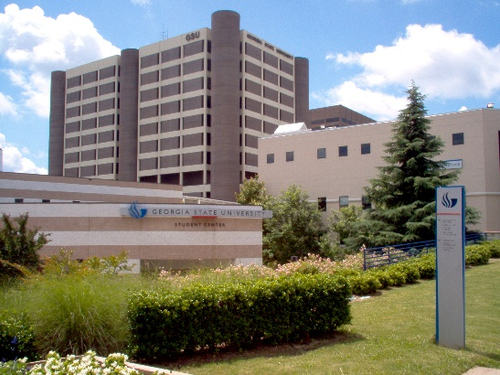

Coursework
William Foster
10-19-15
LT 2010
Prof. Gilleland
Football
My topic is Football. I choice Football because it’s an intense sports and exciting. I don’t really like football I just choice it because it’s an hot topic. Football started off as rugby and soccer in the 1800s. Walter Camp was the first coach in the NFL in 1876. The most watch television show in the United States is the Super Bowl. Its takes about 600 cows to make the football for the whole season. There are 30 teams in the NFL and also 60 mins in each games with four quarter.
The NFL has an annual revenue of $9 billion it’s with a profit of 1 billion. MLB has an annual revenue of $7.2 billion, with a profit of $49 million. So therefore football has more revenue then MLB. NFL is the highest paid professional sport. The famous cheerleaders in the NFL is the Dallas cowboys. Football teams have 11 people on the field at a time. There are 11 positions on the field at an time. A touchdown is worth 6 points, an field goal is worth 3 points, and after a touchdown is made there is extra point or two point conversion.
As of September 2012 the Dallas cowboys had the highest paying franchise in the NFL. The last scoreless NFL game was in 1943. Those teams were the Lions and Giants. The game start off with a coin toss to see who gets ball first. Then there’s the kickoff and the game is started. If the game is tied after regulations its goes to overtime which is, a fifteen minute quarter first with a touchdown win or if the person that gets the ball first at the beginning of the overtime don’t score whoever get any points after that wins.
References
- Biderman, David. “11 Minutes of Action.” The Wall Street Journal. January 15, 2010. Accessed: November 15, 2013.
- Buckley, James, Jr. 1999. Football (Eyewitness Books). New York, NY: DK Publishing.

- Chang, JuJu and Allison Markowitz. “Lingerie Football: So Sexy or Just Sexist? Female Players Say They Love the Game.” ABC News. September 20, 2013. Accessed: November 15, 2013.

- “Cheerleaders.” Dallas Cowboys Cheerleaders.” 2012. Accessed: November 29, 2013.

Resume
William Foster
4656 Mossey Dr. 470-330-6253 Lithonia, Ga 30038 wfoster6@student.gsu.edu
Education:
Georgia State University Expected graduation May 2018 Bachelor of Science, Exercise Science
Work Experience:
New Line Transportation, Lithonia, Ga August 2012-Present Customer Service Representative
- Facilitate with dispatches and drivers
- Filing financial paperwork
- Answer the phone and direct phone calls

Volunteer Experience
Hands on Atlanta – Atlanta, Ga November 2013
- Pass out water to the marathon runners
Books of Africa – Atlanta, Ga November 2013
- Sorts books and pack the books in boxes for shipment
Skills
Interpersonal: Able to follow instructions, strong work ethic
Computers: Microsoft Office—Proficient in Word, PowerPoint, & Excel, Intermediate HTML
Office/Clerical: Type 50 wpm, strong customer service skills

