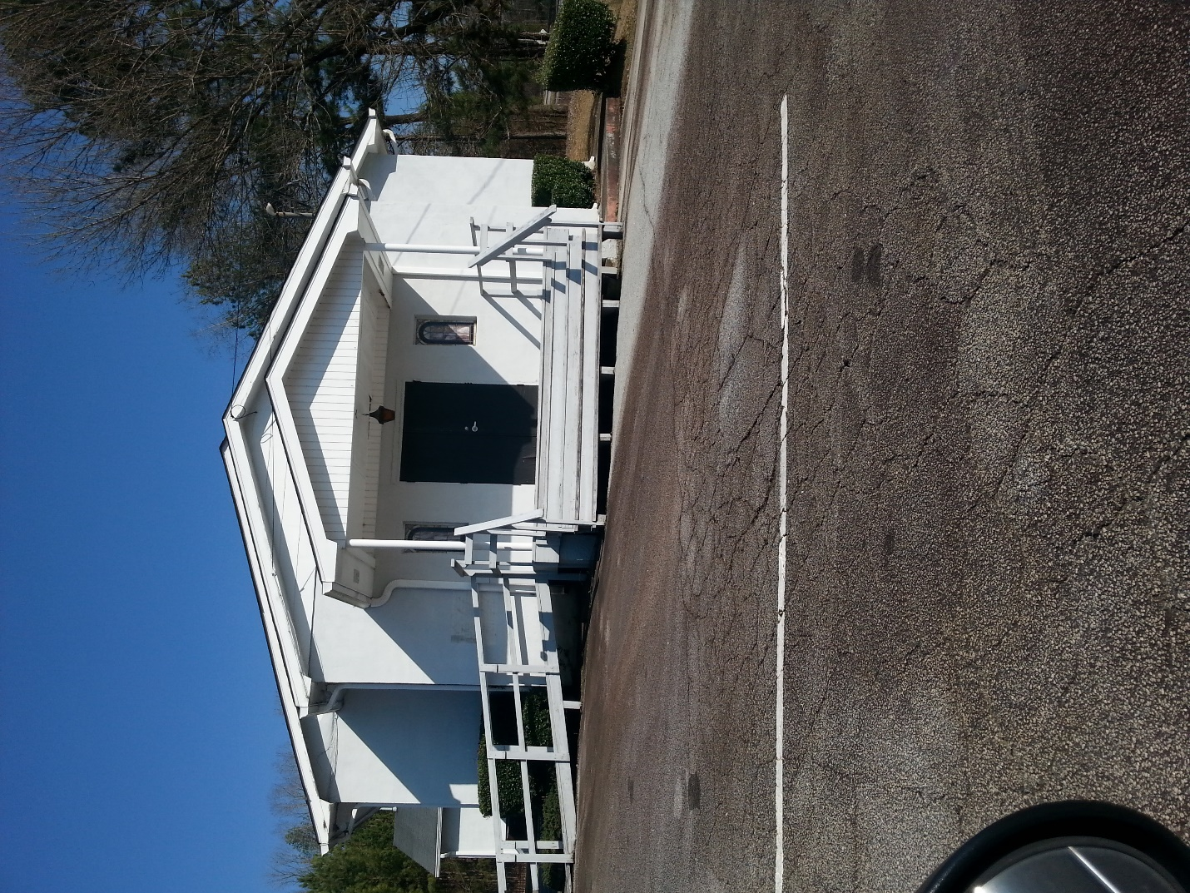

This is a picture of one of the first churches built in the Briarcliff community, it has been in the community for a little under one hundred years. Every year the church is painted a pearl white, the wood is old and in some places needs to be replaced. A few people volunteer and replace the wood to keep the church new, because it’s been around for some generations.

