Who Cares?
Motivation, Growth Mindset, and the “F” Word

Goals
- Students will determine and discuss motivations for doing well in school
- Students will encourage themselves to do homework
- Students will reflect on effort vs innate ability (Growth Mindset)
- Students will discuss failure and take steps to learn from failure and persist

Pre-group preparation
- Write ‘Student Motivations’ list on the board ahead of time for students to complete when they get to group.
- Print out Growth Mindset handout (one for each student) at the end of the lesson
- Have technology available to show Will Smith Video: https://youtu.be/FtLXKJ7lLrs

Materials
- Group agreements and talking piece
- Pens or pencils, student folders
- Marker Board or Butcher Paper/Large Sticky Pad

Starter Activity: Identify your Motivation to do well in school

Write this list of motivations for doing well in school (below) for students on a board – have students put tally marks next to the ones that are true for them as they come in for group. In future groups it would be good to explore those high motivators and why others aren’t motivating.
(Parent, Myself, and College/Career are often the most noted motivating factors)

Athletic Eligibility/Participation Requirements
College/Career Plans
Friends
Incentives at home (money, clothes, special..)
Incentives at school (extra credit, special rewards, food..)
Myself
Parent
Teacher
Support Staff (non-teacher, mentor, etc.)
Other:______________________________

Ice Breaker Questions: Who Cares?
How do you know that a teacher cares about you?
How do you know that a teacher doesn’t care about you?
Optional: Is this different for Friends, Family, Mentors, or others in your life?

Activity: Brainstorm Clouds on Homework (Draw on Board)
Source: The Best of Building Assets Together by Jolene L. Roehlkepartain.Copyright 2008 by Search Institute; 1-800-888-7828; www.search-institute.org
1. Write the prompts inside ‘Brainstorm’ Clouds and have student share as many ideas as they can.

If a friend asked you for help in figuring out how to do homework better, what advice would you give?
What keeps you from doing homework?
What would encourage you to do homework?

2. Remind students to give as many ideas as possible and that there are no bad ideas.

Activity: Growth Mindset (Handout)
1. Print out the Handout at the end of the document. Have students in group read through the statements independently. Have students circle statements that they agree with.
2. Have students look at their circles. Based on their circles, do they believe ‘effort’ matters? Have students discuss this.
3. Show Will Smith ‘Mindset’ Video: https://youtu.be/FtLXKJ7lLrs (Show on your computer, phone, have students view it on their phones)
4. Discuss Will Smith Video – what do students agree with? Disagree with?

Activity: The “F” Word: Failure
Adapted from: www.ventureteambuilding.co.uk/the-f-word-learning-from-failure/

Note to Mentors: Okay, so not that F word – the other one, ‘Failure’. When we hear the word we think only negative thoughts but why is failure considered so bad? Besides the obvious fact that failing doesn’t feel particularly good; failure provides an opportunity to learn through the experience, teaches resilience and allows you to adapt and refine your approach on your road to success. It is important to understand that failure of some sort is unavoidable and to be expected – it’s simply a part of life. In order to move forwards and develop, you have to step out of your comfort zone and take risks and with these risks you either fail or succeed. Failure and learning through self-discovery is the best teacher. It forces you to reflect and review your methods. And importantly, failure will eventually lead to success, if you remain adaptable and flexible in your approach.
Think about this …Students who fail in video games do not suffer the same blow to their self-esteem as those who receive a low grade on an exam or report card. They simply try it again.
1. Introduction: Read the below information to students.
Failure means you’re developing. Every time you try something new or your face a challenge you run the risk of failing – the most important thing is that you must learn from the experience and make a change. See failure for what it truly is… learning, feedback and a chance to adapt your plan of attack.
Despite failing, many people don’t take time to reflect and keep trying the same approach or method only to end up with the same results. Failure doesn’t necessarily mean we are bad at something, it just means we have to try something new.
2. Have students think of a failure (can be inside or outside of school). If students are comfortable share; mentors this would be an opportunity to give an example of a failure for yourselves too – no one is perfect! Give an example and Remind students: Failure presents an opportunity to learn from something and try a different approach.
3. Guide students through the following questions…
- What did I learn from this failure?
- Why did I fail?
- What could I have done differently?
- Where do I need to improve to succeed next time?

Asking these questions and answering as thoroughly as possible will provide you with invaluable insights, which can help move you past your current situation and towards the achievement of your goal or outcome.

Closing: End on a Positive
Have students brainstorm a list of things they didn’t know how to do at some point in their life (ex: riding a bike, playing a sport, learning multiplication facts, etc.)
Give themselves a pat on the back for accomplishing these things!

*Help students make a connection to more difficult things they are trying to accomplish right now (getting good grades, coming to school on-time, getting along with their teachers) they have accomplished things before and they can do this too!

Optional: Have students compliment each other on goals accomplished/things they learned

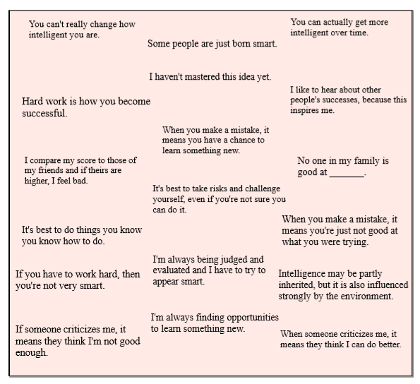
Directions: Circle the statements that you ‘agree’ with.

Discussion: Do you believe EFFORT matters?

After Video Discussion: Do you agree with Will Smith? Why or why not?

