BY CRAIG HEURING APRIL 2016
FAD FREE FITNESS

What’s inside

- What makes our magazine different…Pg 3

- Identifying fad free diets…Pg 4

- Affordable in-home
exercise equipment…Pg 8

- And Much More!
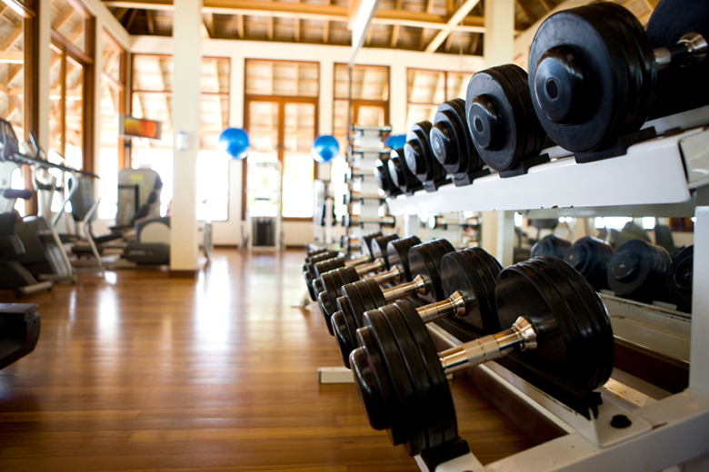
MISSION STATEMENT:

Fad Free Fitness Magazine is dedicated to providing its readers with the most up-to-date science and research behind proper nutrition, various exercise modalities, and pre-habilitation/re-habilitation techniques. Our goal is to enhance the knowledge about physical fitness to the general population. We will take every step necessary to give the most reliable, valid, and truthful information about ways to improve the health of our communities and the individuals within them. Honesty and integrity is what we pride ourselves on, and every individual involved in our magazine takes the utmost care of our values when providing tips and techniques about physical fitness and eliminating nutritional and exercise myths in a rapidly growing industry.

WHAT MAKES US DIFFERENT

Some of our competitors, such as “Box Life Magazine”, focus on a workout philosophy and belief that maximal exertion is the only way to achieve great results. It is a growing fad that if you are not throwing up after a workout then you didn’t push yourself hard enough. We understand that high intensity work must be incorporated into a workout program, but we want to provide you with information about the importance of rest and proper active recovery. Over-training can lead to a decline in fitness performance and an increase in your risk for injury.

Some fitness magazines, such as “Muscle and Fitness Magazine”, have great information about muscle growth and toning. The problem is they tend to lack articles about the importance of range of motion development, flexibility training, and mobility exercises. Building muscle without maintaining or developing proper range of motion can lead to muscle stiffness and potential for damage to tendons and ligaments by overloading certain joints. In our magazine we will make sure to give you the knowledge needed for developing complete body health.

There are many magazines, such as “Women’s Health”, that want to offer you a quick fix to your fitness needs. Not only does our magazine apply to both male and female readers, but also we will give you the truth about developing and maintaining a healthy body. We will prove wrong the idea of a “5 min workout that will give you a six pack in 10 days”, or “all you have to do is drink this shake and you will lose 30lbs in a month”. These suggestions are either false or unsafe. We will make sure you know proper ways to exercise and diet that will be done in a safe manner and help you to keep the weight off once you have lost it.

Identifying A Fad Diet

We’ve all heard the sales pitches about how losing weight is easy and if you try their shake or stop eating carbs that you will lose a ton of weight fast. The reality is that achieving a negative caloric balance throughout your day or week will lead to weight loss. This is a simple concept, but with how fast and stressful our everyday lives are it can be difficult to execute. I want to discuss several ways to identify a fad diet that is either unrealistic or an unsafe practice when trying to keep weight off in order to live a longer and healthier life.
One of the easiest ways to spot a fad diet is to determine whether or not it completely excludes one or more food groups. This method of dieting will prevent your body from getting some of the essential nutrients that it needs to function at peak performance levels throughout the day or during a workout. You should never completely eliminate a food group from your diet, but rather find a balance to meet your specific goals. For example, if you are trying to lose weight it is recommended to reduce your carbohydrate intake and increase your protein and fat consumption. You do not want to complete remove this macronutrient from your daily caloric intake, but rather adjust the percentage you are taking in each day. This same concept can be applied to a diet that overemphasizes a particular food or type of food. This type of diet is too restrictive for clients to stay on for a long periods of time, and may lead to deficiency in certain nutrients.
Another red flag is when a diet promises quick weight loss and is an extremely low-calorie diet. Weight loss diets can be effective when reducing calories, but when daily caloric intake is too low there is the potential for an increase loss of lean muscle tissue. This will have a negative effect on daily energy levels and fitness performance. The same can be
said about a diet the claims physical activity is not necessary. In order for this diet to show results, it would have to be extremely low in calories and your muscles tissue would begin to breakdown from the lack of stress placed upon them. Exercise is crucial for preventing the breakdown of muscle fibers and maintaining proper strength and range of motion.
Here is a quick recap of a few ways to identify a fad diet. A fad diet may completely eliminate a food group or over emphasize one particular food type, it is extremely low in daily caloric intake, it promises quick loss, and discourages physical activity or states that it is not necessary. It is much safer to adjust the percentage of carbohydrate, protein, and fat consumption to create a negative caloric balance, which will allow your body to receive the nutrients it needs and achieve your desired goals.
.
WHOLE FOODS MARKET

Whole Foods has an excellent supply of organic foods that will meet all of your nutritional needs. You don’t need to worry about processed foods when shopping in our organic food section. Come see what we’re about at your local Whole Foods grocery store, or search our food options online at http://www.wholefoodsmarket.com/

Static Stretching vs. Dynamic Stretching Warm-up

It is very common to see athletes or members in a gym warming up with static stretching. There may be other instances where you’ve seen individuals doing a more complex warm-up that involves lunges or some form of squatting. I will describe in this article the benefits to utilizing a dynamic stretching warm-up over a static stretching warm-up to improve performance during your workout routines.
I would first like to define the difference between a dynamic stretch and a static stretch. A dynamic stretch is type of stretch that moves a muscle and joint through its full range of motion. On the other hand a static stretch is a form of stretching that that pulls the muscle into a static position and is held for a certain period of time (10-30 sec). It has been shown that there are several reasons why the method of a dynamic stretching warm-up results in a safer and more effective workout.
Dynamic stretching allows the neuromuscular system to begin sending signals to motor-units for contraction. This stimulation of the nervous system prepares it for the demands it will soon face during the workout. Static stretching does not activate the nervous system in this manner, which will decrease performance following the warm-up. In addition to stimulating the nervous system and motor-units, a dynamic warm-up begins to move your muscles through a full range of motion that will help to mirror some of the movement patterns performed throughout the workout. This will create blood flow to the working muscles and help to prevent injury by reducing joint stiffness. A dynamic warm-up also allows the individual to prepare mentally for the exercises that are about to be performed. By actively moving during the warm-up, it will increase heart rate and help the individual to
focus on balance and movement patterns. Static stretching does not accomplish this as it focuses on flexibility training, which is a more relaxing stretch and does not increase heart rate or mental preparation for muscle and joint movement. Static stretching is best performed post-workout when there is a steady blood flow to the working muscles and flexibility as well as reducing delayed onset muscle soreness is the primary goal.
In conclusion, movements such as the walking lunge, hip rotation, and arm circles will improve performance and reduce the chance of injury if implemented into a dynamic stretching warm-up. Static stretching has several benefits to improving flexibility, but is best utilized post-workout as a form of cool-down rather than a warm-up.
.
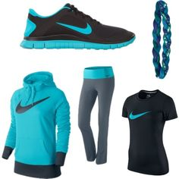
NIKE….

Looking for a new comfortable cool workout look this year?

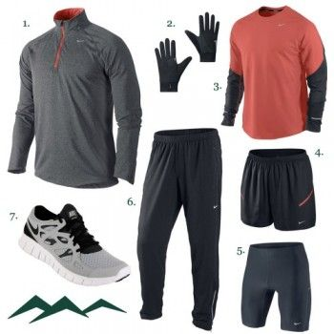
Nike has some of the most comfortable and stylish shoes and clothing on the fitness market. We have everything you could want in your fitness apparel wardrobe. Check out our online store and your apparel shipped today.
http://www.nike.com/us/en_us/

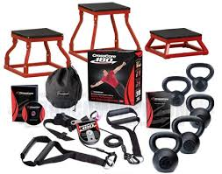
Exercise Equipment That Will Get You The Biggest Bang For Your Buck!

It can be very difficult to decide what type of exercise equipment to buy. Most of us either hate to spend a lot of money on exercise equipment that turns out to not be worth our money, or we do not have the finances to afford extremely expensive fitness equipment. I would like to fill you in on a couple of suggestions for equipment that will get you the most value for you money.
One of the most affordable and versatile pieces of equipment you can buy is resistance bands. Resistance bands can be used in many ways to work almost every muscle group of the body. For example, they can add extra resistance to your body weight squats, and are easy to transition between exercises during circuit training (i.e. going from bicep curls to tricep extensions). In addition, resistance bands are small and easy to store and travel with. They will not take up much space in your home, and it’s as simple as throwing them in a backpack with you to take to the gym or on vacation. These bands come in different colors and resistances, so determine a good resistance for your fitness level. It may also be beneficial to purchase a couple of bands with different resistances.
Another piece of weight equipment that will get you your biggest bang for your buck is kettlebells. If you are not familiar with kettlebells, they are similar to a dumbbell but have a different design that allow for better functional use during dynamic movements. Some examples include leg strengthening during goblet squats, hamstring and gluteal strengthening during kettlebell swings, and shoulder movements such as an arnold press. There are a wide variety of kettlebell weights to choose from, and they are considered one of the best options for in home weight training.
In summary, resistance bands and kettlebells are only a couple items that you can purchase for in home fitness that is worth the value. You do NOT need to buy a $3,000 electronic weight machine in order to get an effective full body workout. Characteristics such as versatility, size, and performance are keys to identifying equipment that you will not regret purchasing.
.

Your personal training career starts here

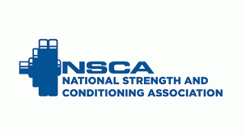

The National Strength and Conditioning Association is one of the most elite training organizations in the world. We offer several certifications, such as NSCA-Certified Personal Trainer and NSCA-Certified Strength & Conditions Specialist. Get started on your career by visiting our website at https://www.nsca.com/ to find out more information about study material and testing locations.
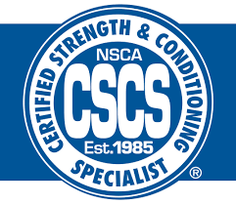

Go Fit - Superbands
Go Fit superbands are one of the hottest exercise items on the market. They can be used for improving flexibility, increase exercise intensity, and enhancing sports performance. Step up your fitness game by incorporating them into your workout routine. Order yours now at https://www.gofit.net/index.php/super-bands.html
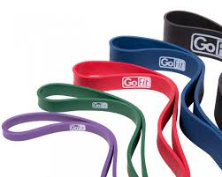
.
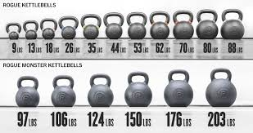
Rogue Exercise Equipment

Rogue exercise equipment is dependable, affordable, and well respected throughout the fitness industry. We have everything from kettlebells to squat racks. Our concept 2 rowing machine is being used all the way from in-home gyms to university athletic departments. Shop online at our website, http://www.roguefitness.com/, so that we can help you meet your apparel, nutritional, and fitness needs.
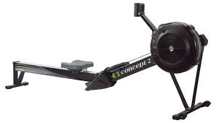

REFERENCES

Coburn, J., & Malek, M. (2012). NSCA’s Essentials of Personal Training. Pg. 118-120.

https://www.hss.edu/conditions_stretching-tips-athletes-dynamic-static.asp

http://www.bodyscapesfitness.com/the-benefits-of-dynamic-stretching-vs-static-stretching/

http://abmachinesguide.com/home-exercise-equipment/

